# **The city of Zalam**:

### **Overview:**

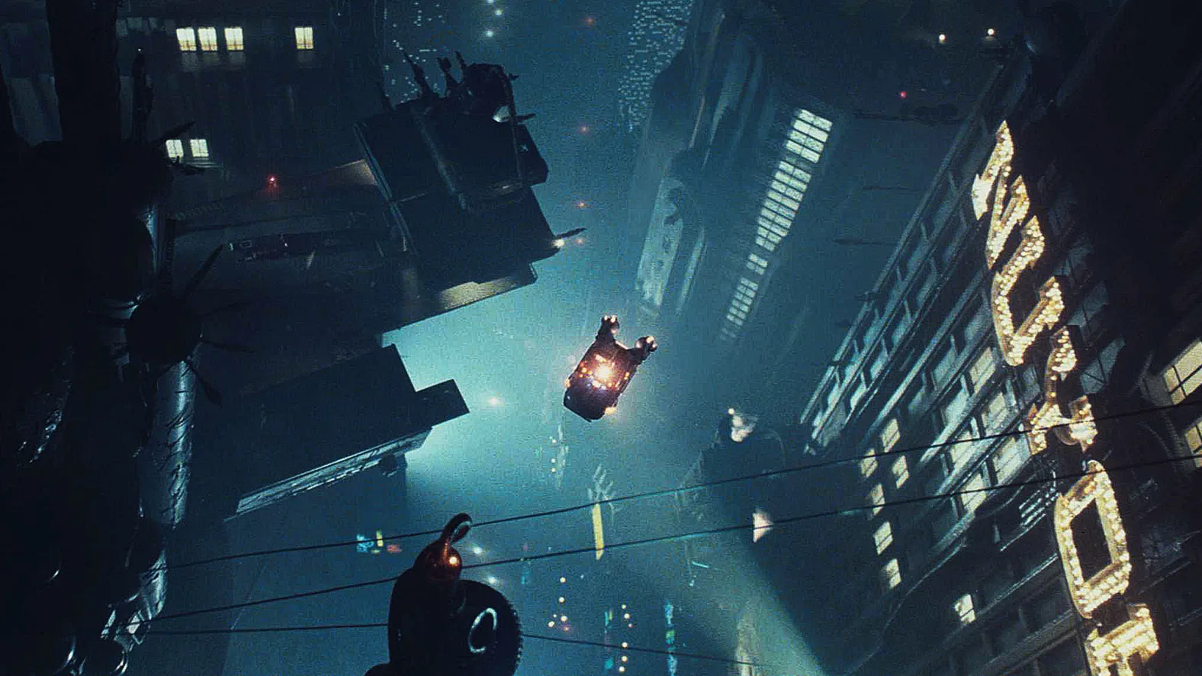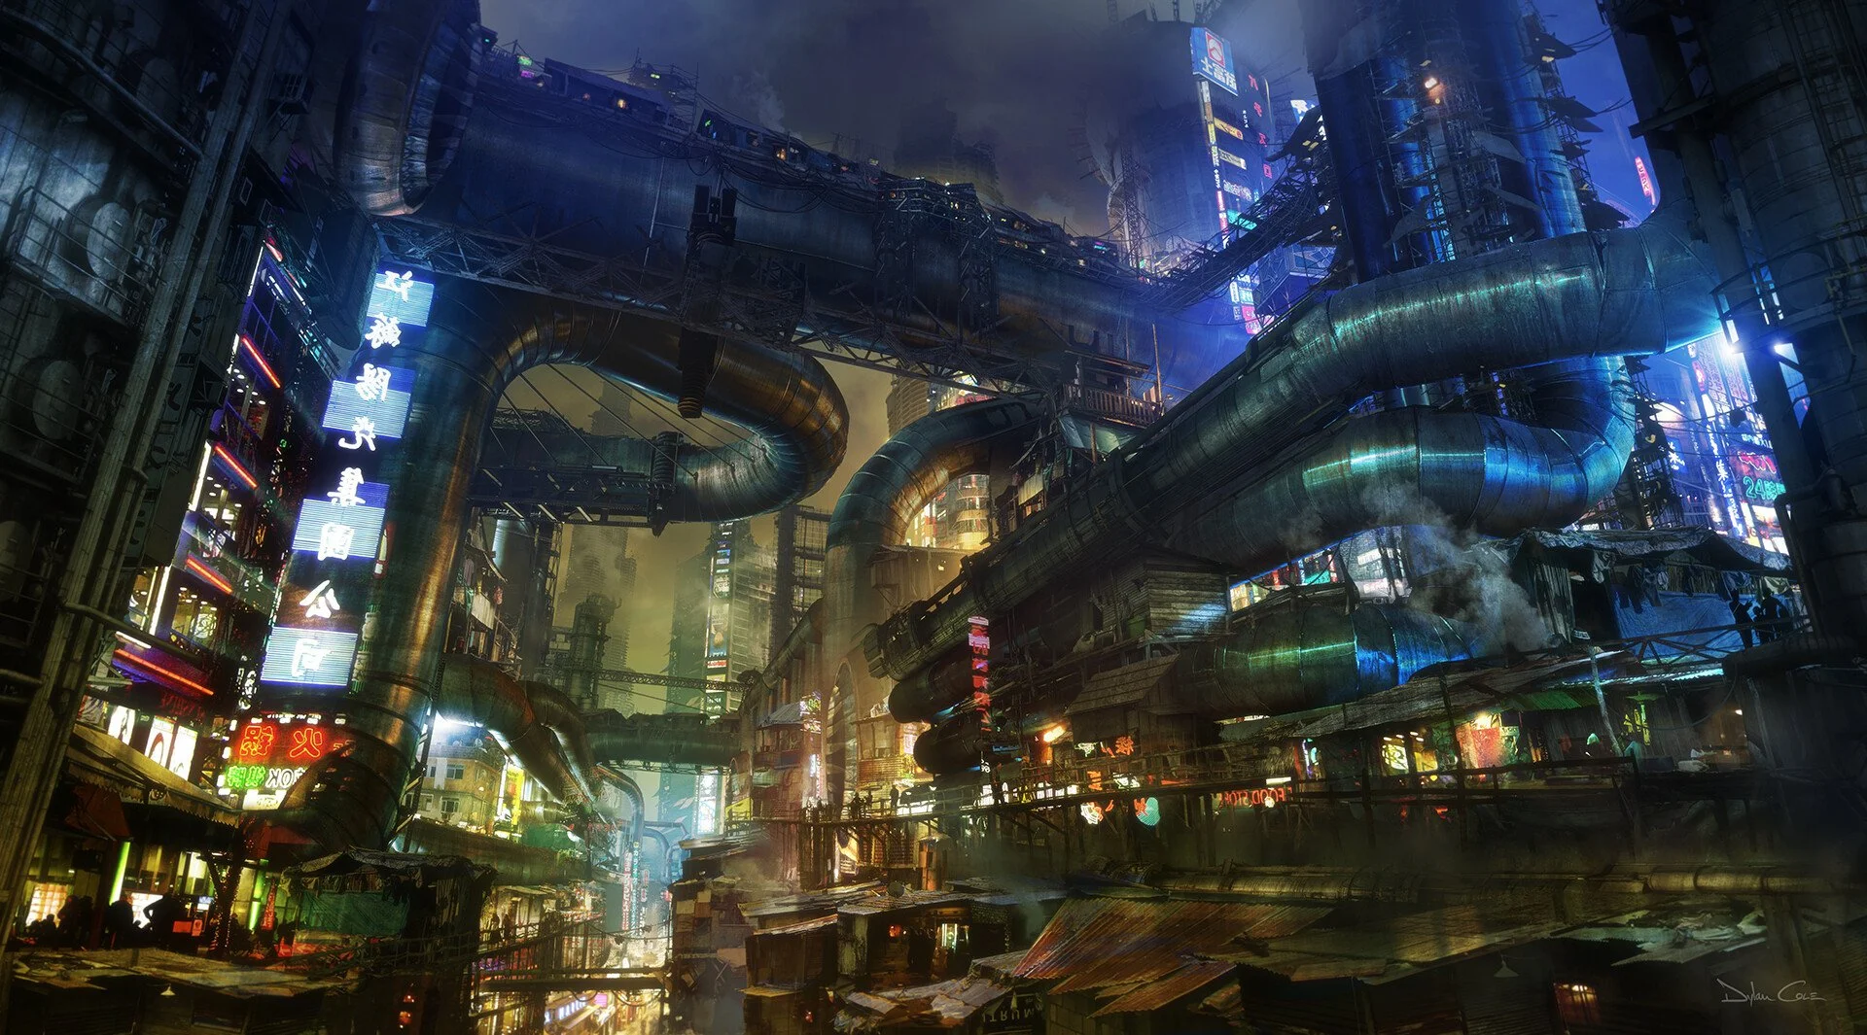 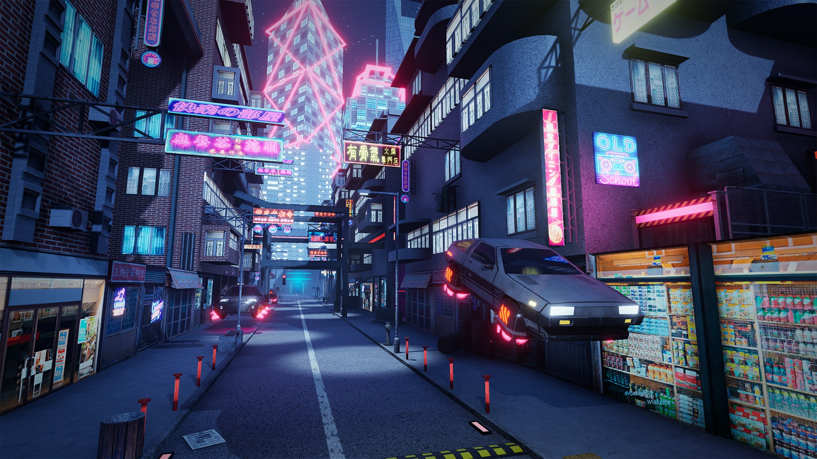

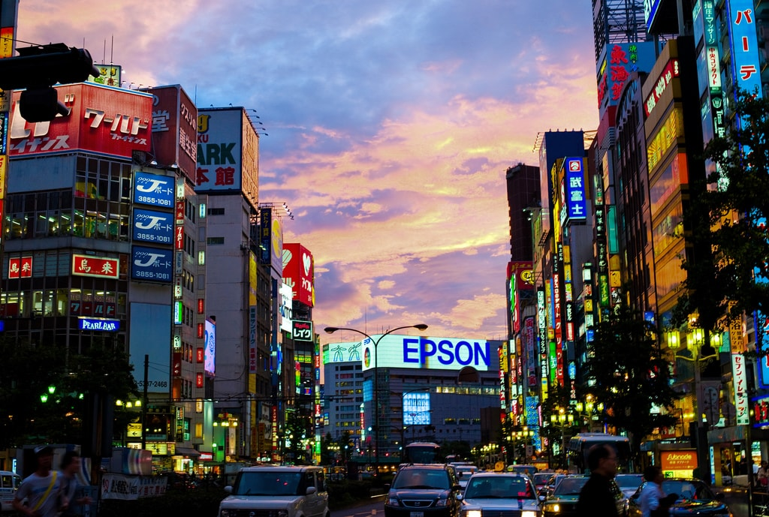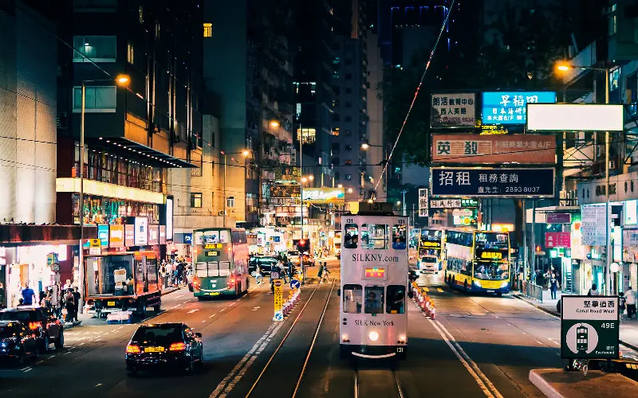

**Zalam**, well-known as “the City of Magic”, is a port city and the second-largest city of **Livori**. It’s the cultural and economic center of the country.

Zalam has been famous for being an important merchant route since the antique. To facilitate tradings, the city developed a multicultural and diverse type of lifestyle and quickly became one of the most prosperous cities in the world. Now, Zalam has gathered the best minds from the world. Not only it has the biggest stock exchange **ZASE (Zalem Association of Stock Exchange)** on **Suhaj Avenue, Shuri district** is also known as the greatest innovation center that specializes in Artificial Intelligence and Robotics**.**

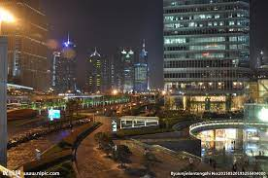

### **Recreations & Attractions:**

**Monroe Street** is only a block away from ZASE, where it was dedicated to hawkers before ZASE was founded, and now it’s one of the biggest regions for recreation and entertainment.

**Oasis 1997** was by far the most popular club. If you want to meet celebrities and enjoy some high-end nightlife on a weekend night, make sure to get there early before the crowd.

